

**كلية العلوم الحاسوبية والمعلوماتية**

**College of Computer and Information Sciences**

Hotel Booking Application

*Students:*

|  |  |  |
| --- | --- | --- |
| **Yazan Mohammad Amin** | **202010454** | [**yznbrhm77@gmail.com**](mailto:yznbrhm77@gmail.com) |
| **Basel A’yesh** | **202110128** | [**baselayesh46@gmail.com**](mailto:baselayesh46@gmail.com) |

*Supervisor:*

**Dr. Alaa Abu Dhawabah**

*A project report submitted in partial fulfillment of the requirements   
for B.Sc. degree in Software Engineering.*

*Amman - Jordan*

*2024/202**5*

**Table of contents**

|  |  |
| --- | --- |
| Table of Content | 2 |
| List of Figures | 3 |
| List of Tables | 4 |
| ABSTRACT | 5 |
| SCENARIO | 5 |
| Chapter One: Introduction | 6 |
| 1.1 Problem Statement and Project Scope | 6 |
| 1.2 Project Plan and Schedule | 6 |
| 1.2.1 Activity, Predecessor, Duration (days) | 7 |
| 1.2.2 Critical Path | 8 |
| 1.2.3 Work Breakdown Structure (WBS) | 8 |
| Chapter Two: System Analysis | 9 |
| 2.1 System Analysis | 9 |
| 2.1.1 Functional Requirements | 10 |
| 2.1.2 Non-Functional Requirements | 11 |
| 2.1.3 Use Case Diagram | 12 |
| 2.1.4 Class Diagram | 13 |
| 2.1.5 Sequence Diagram | 14 |
| 2.1.6 Activity Diagram | 16 |
| 2.1.7 Data Flow Diagram (DFD) | 17 |
| Chapter Three: System Design | 18 |
| 3. System Design | 18 |
| 3.1 ER-Diagram (if a database will be used) | 19 |
| 3.2 User Interface (prototype) | 20 |

List of Figures

|  |  |  |
| --- | --- | --- |
| Figure 1 | Gant Chart | 6 |
| Figure 2 | Critical Path | 8 |
| Figure 3 | WBS | 8 |
| Figure 4 | Use a Case Diagram | 12 |
| Figure 5 | Class Diagram | 13 |
| Figure 6 | User Register Sequence Diagram | 14 |
| Figure 7 | User Login Sequence Diagram | 14 |
| Figure 8 | User Reserve a Room Sequence Diagram | 15 |
| Figure 9 | Activity Diagram | 16 |
| Figure 10 | DFD | 17 |
| Figure 11 | ER-Diagram of Appointment System | 19 |
| Figure 12 | Start | 20 |
| Figure 13 | Login | 20 |
| Figure 14 | Explore | 21 |
| Figure 15 | Filters | 21 |
| Figure 16 | Where to | 22 |
| Figure 17 | Place | 22 |
| Figure 18 | Wish Lists | 23 |
| Figure 19 | Trips | 23 |
| Figure 20 | In Box | 24 |
| Figure 21 | Profile | 24 |
| Figure 22 | In Box | 25 |
| Figure 23 | Personal Info | 25 |
| Figure 24 | Payment & Payouts | 26 |
| Figure 25 | Translation | 26 |
| Figure 26 | Notifications | 27 |
| Figure 27 | Privacy and Sharing | 27 |

List of Tables

|  |  |  |
| --- | --- | --- |
| Table 1 | Project activities, its predecessor, and its duration | 6 |

ABSTRACT

A hotel booking app is an important part of modern hotel life, it ensures good work and efficiency of the hotel and provides the option to book a room online. Analyze and improve the modern booking application. Our goal is to provide application analysis. In relation to hotels, reservations, online reservations, and online reservation systems. To create UML diagrams that show how this application works.

SCENARIO

The hotel booking app provides online room booking service through a mobile app called Hotel-Rest. The application provides easy and convenient ways to book rooms. You as a system designer are asked to design the following scenario that explains all the details that a hotel booking application needs to cover. Guests can book a room using the hotel app.

After the application receives the request, the administrator needs to collect the guest's information and enter the booking request into the system. If ordering through the app, the guest must register in the app and then provide the requested flight information. Once the reservation request is received in the system, the system checks the details of the reservation requests and finds the matching available room. Once a matching room is identified by the system, the guest is notified through app alerts. If the guest accepts the room offered, they must accept the reservation by responding in the app. There are workers working in the rooms and reservations. After booking the room, the guest needs to submit payment in three possible ways (manually by cash, by credit, or online through the application). The last step for guests is to rate the hotel.

Chapter One: Introduction

* 1. Problem Statement and Project Scope

The system has been facing problems due to its paper-based appointment

system. With the increase in the number of patients visiting, it has

become diﬃcult to manage the appointment system manually. Recording

of appointments and creating registers by pen and paper has become a

Problem Statement: The current hotel booking process is rife with inefficiency and frustration for both customers and hotel staff. Customers often face challenges finding available rooms, navigating complex booking platforms, and ensuring secure payment transactions. Hotel staff are having difficulty managing room availability, updating prices and availability in real-time, and providing timely customer support. These issues lead to customer dissatisfaction, potential loss of hotel revenue due to overbooking, and increased operating costs.

Project Scope: The scope of our project is to develop an easy-to-use and efficient hotel booking application. This application will enable customers to easily search for available rooms, view detailed information about each room, make reservations securely, and obtain instant confirmation. The application will provide hotel staff with a comprehensive control panel to manage room availability, update prices and availability in real-time, track booking, and communicate with customers effectively. By simplifying the booking process and enhancing the overall user experience, our app aims to improve customer satisfaction, increase hotel revenues, and improve operational efficiency.

* 1. 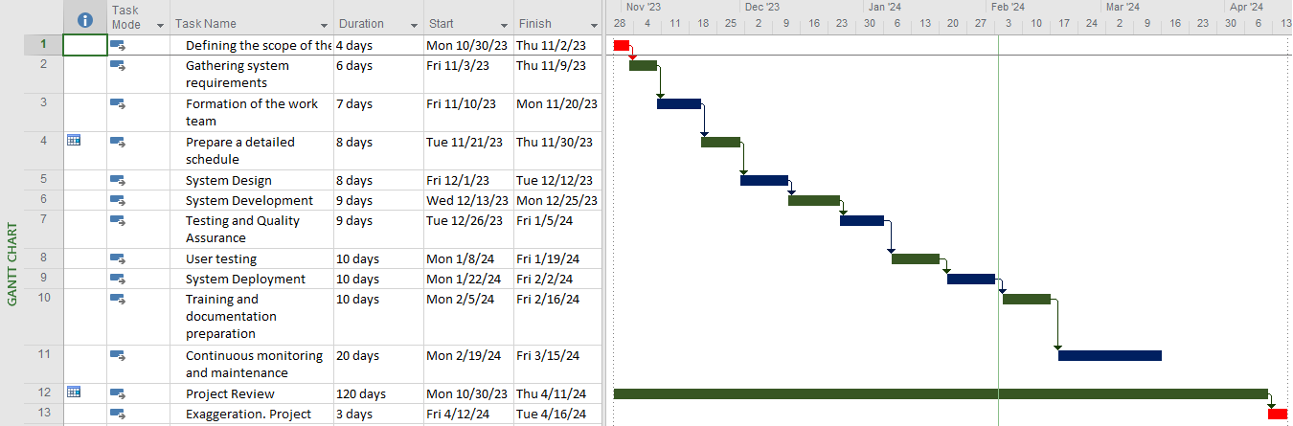Project Plan and Schedule

Figure (1): Gantt Chart

|  |  |  |
| --- | --- | --- |
| Activity | Predecessor | Duration (days) |
| Defining the scope of the project |  | 4 |
| Gathering system requirements | 1 | 6 |
| Formation of the work team | 2 | 7 |
| Prepare a detailed schedule | 3 | 8 |
| System Design | 4 | 8 |
| System Development | 5 | 9 |
| Testing and Quality Assurance | 5 | 9 |
| User testing | 6,7 | 10 |
| System Deployment | 8,9 | 10 |
| Training and documentation preparation | 10 | 10 |
| Continuous monitoring and maintenance | 11 | 20 |
| Project Review | 12 | 120 |
| Exaggeration Project | 13 | 6 |

1.2.1 Activity, Predecessor, Duration (days)

Table (1): Project activities, its predecessor, and its duration

1.2.2 Critical Path

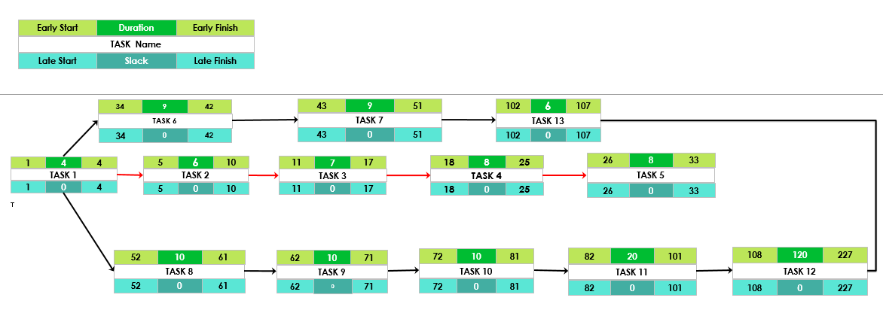

Figure (2): Critical Path

1.2.3 Work Breakdown Structure (WBS)

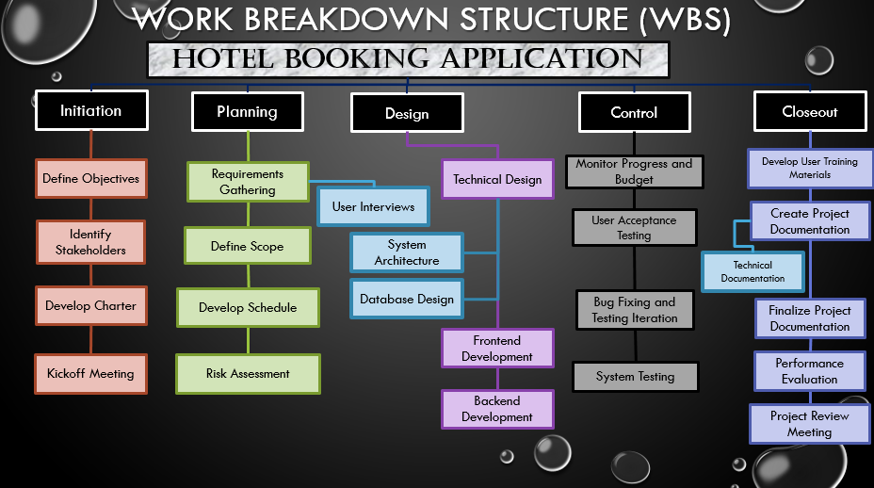

Figure (3): WBS

Chapter Two: System Analysis

2.1 System Analysis

the process of identifying and documenting system requirements and analyzing them to ensure that user requirements are understood and to ensure that the system properly meets these requirements. *Here are some important points in system analysis:*

1. Determine requirements: We must define all the requirements related to the hotel booking application, including the basic functions that the application must perform and additional requirements such as security and performance.

2. User Analysis: We need to understand the app users and their needs, including customers who search for hotels, employees who manage reservations, and hotel managers who need to manage data.

3. Analysis of current processes: We must examine the current processes of hotel booking, whether manual or online, to understand how these processes can be improved through the application

4. Data Analysis: We need to identify and analyze all the data that will be stored and used in the application, such as hotel data, booking, and users.

5. Security and privacy analysis: We must determine the security and privacy requirements of the application, including protecting user data and financial transactions and ensuring that there are no security vulnerabilities.

2.1.1 Functional Requirements

1. User Registration:

* Users must be able to create accounts with unique usernames and passwords.

2. Room Search:

* Users should be able to search for available rooms based on criteria such as dates, location, and room type.

3. Room Reservation:

* Users should be able to select specific rooms, enter reservation details such as check-in/check-out dates, and confirm their booking.

4. Payment Processing:

* The system must process booking payments securely using different payment methods such as credit / debit cards, and online payment platforms.

5. Manage Reservation:

* Hotel staff should have access to a dashboard where they can manage room availability, view current reservations, and update room availability in real-time.

6. Notifications:

* Users should receive confirmation emails or messages upon successful booking, as well as reminders or notifications about upcoming bookings.

7. Cancellation:

* Users should be able to cancel their bookings within a specified time frame and receive refunds by the cancellation policy.

2.1.2 Non-Functional Requirements:

1. Security:

* The system must implement strong encryption protocols to protect user data and payment information.

2. Performance:

* The application should be responsive and able to handle many concurrent users without any slowdowns or major errors.

3. Scalability:

* The system must be scalable to accommodate the increasing number of users and increased demand for booking.

4. User Experience:

* The user interface should be intuitive, easy to navigate, and visually attractive to enhance the user experience.

5. Reliability:

* The system must be reliable, with minimal downtime for maintenance and updates, to ensure continuous availability to users.

6. Compatibility:

* The app should be compatible with a variety of devices such as computers and smartphones.

7. Accessibility:

* The system must comply with accessibility standards to ensure that users with disabilities can access and use the application effectively.

2.1.3 Use Case Diagram

Hotel Booking App

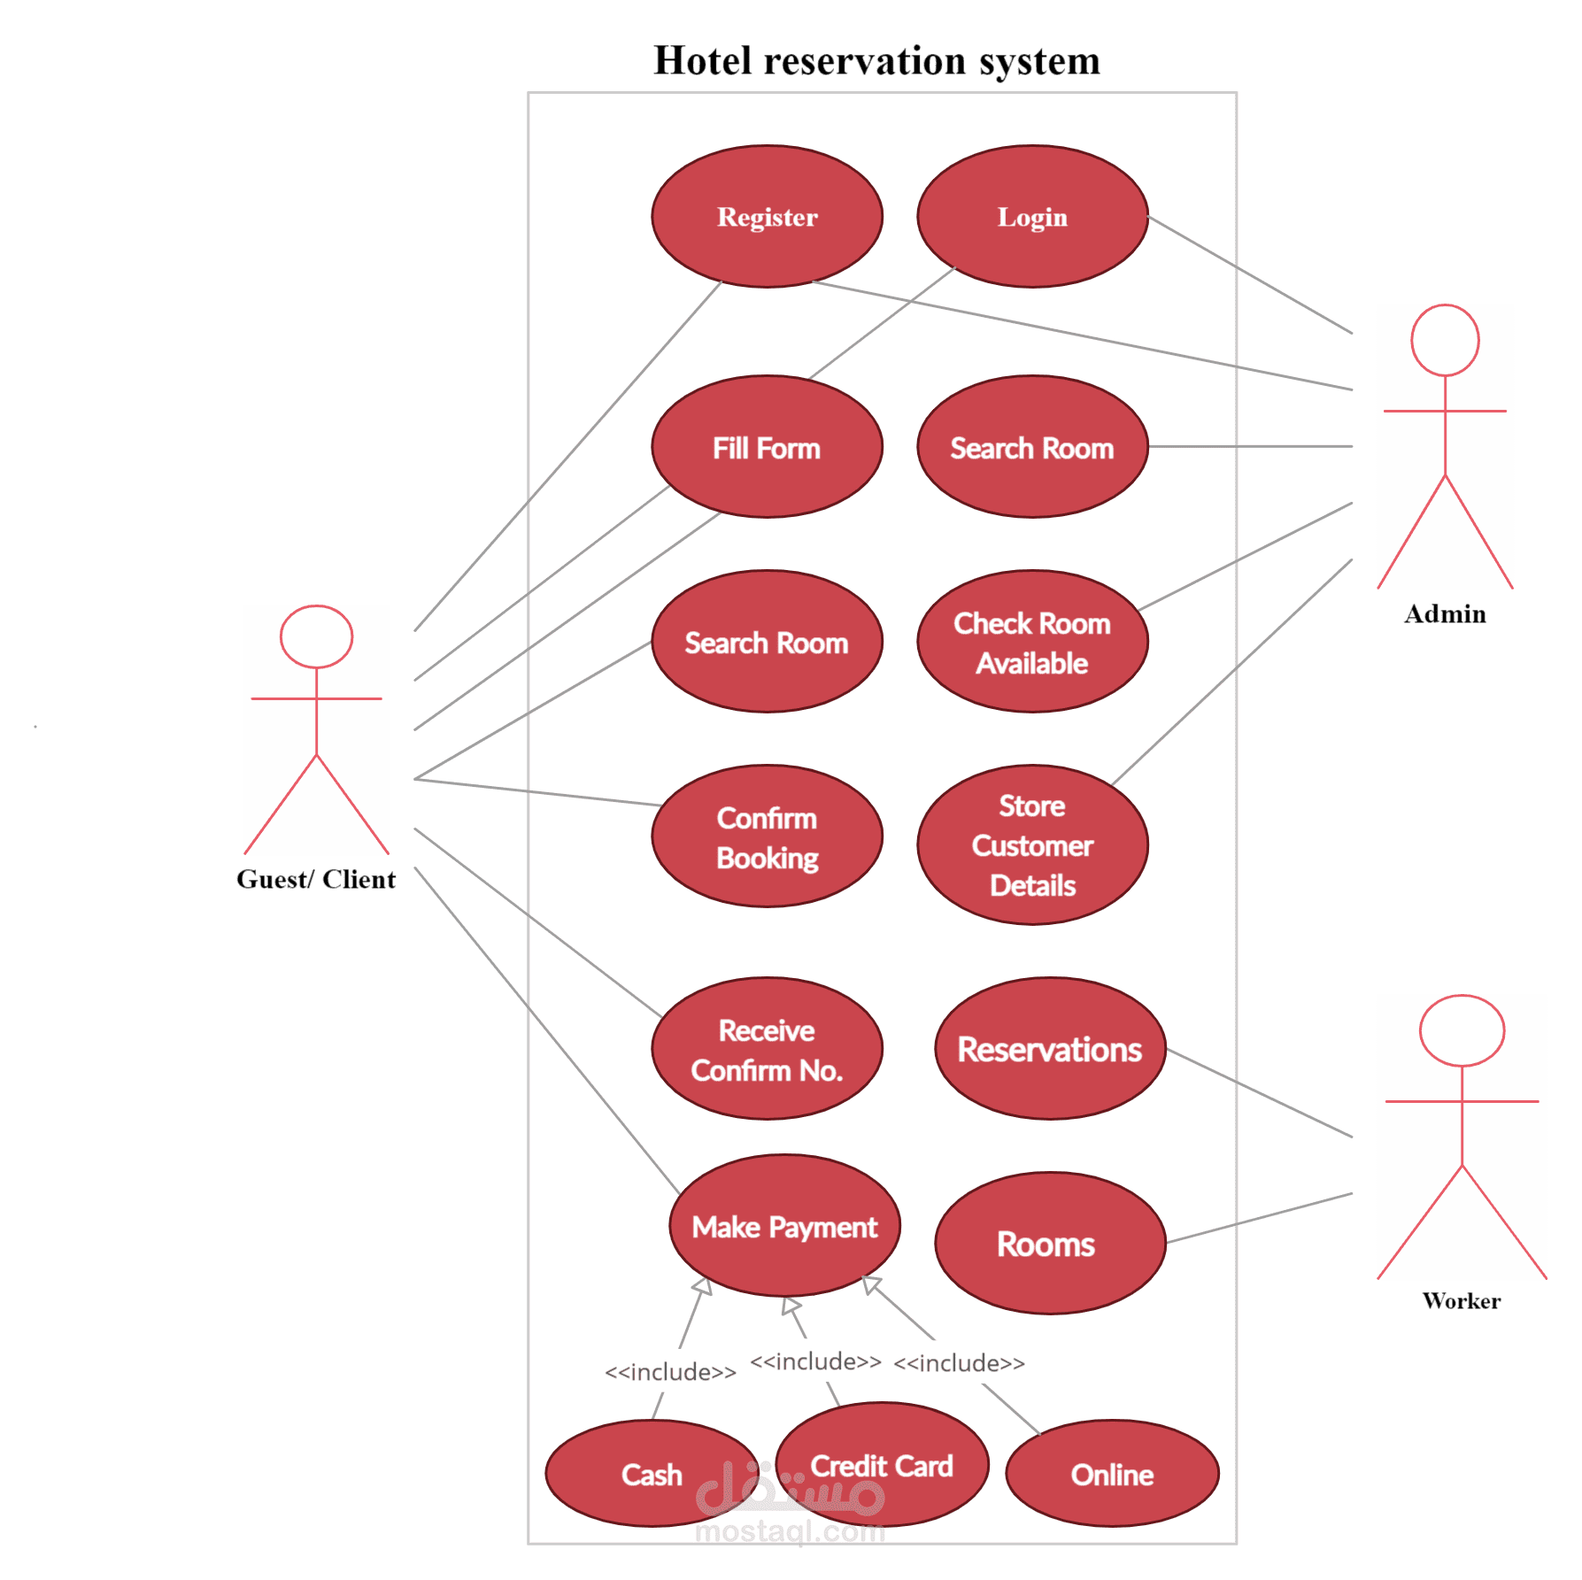

Figure (4): Use a Case diagram of a system

2.1.4 Class Diagram

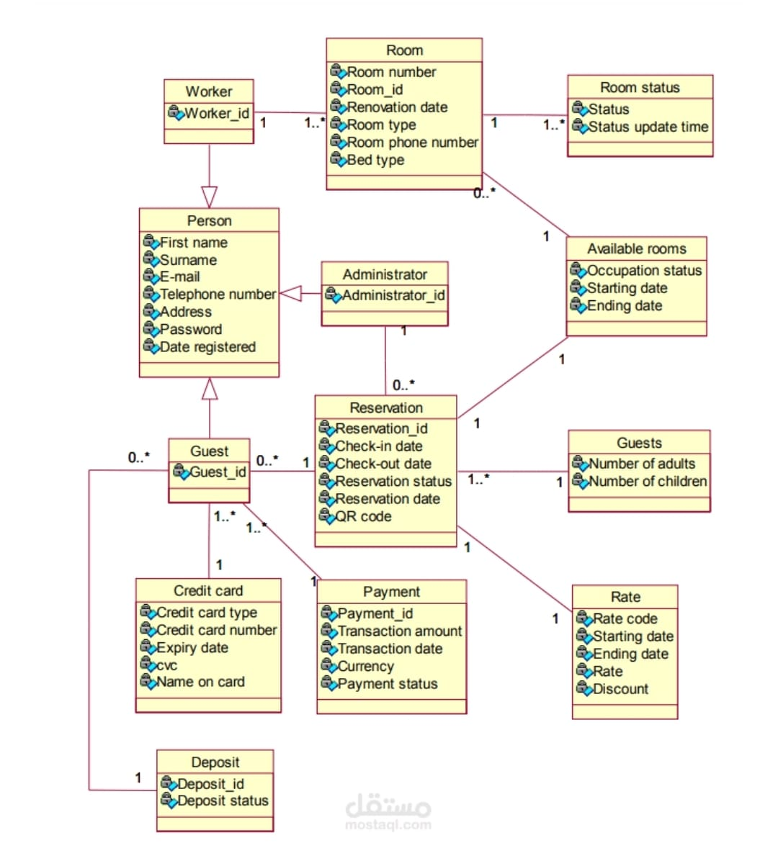

Figure (5): Class Diagram

2.1.5 Sequence Diagram

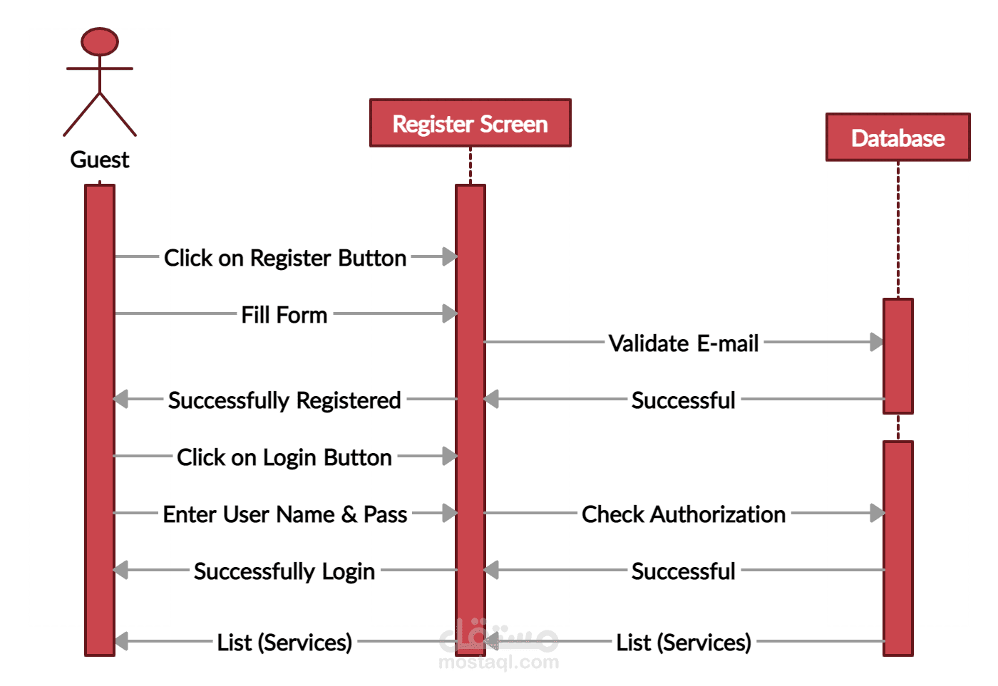

**Figure (6): User Register Sequence Diagram**

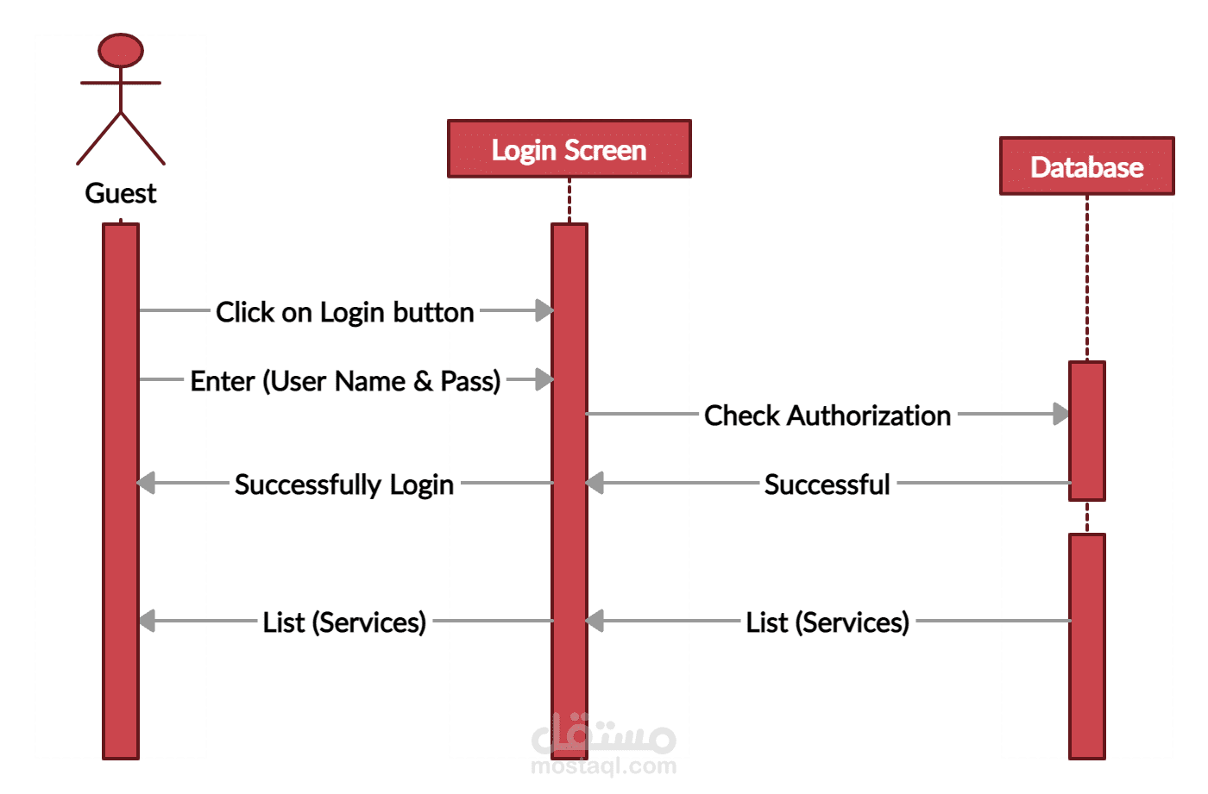

**Figure (7): User Login Sequence Diagram**

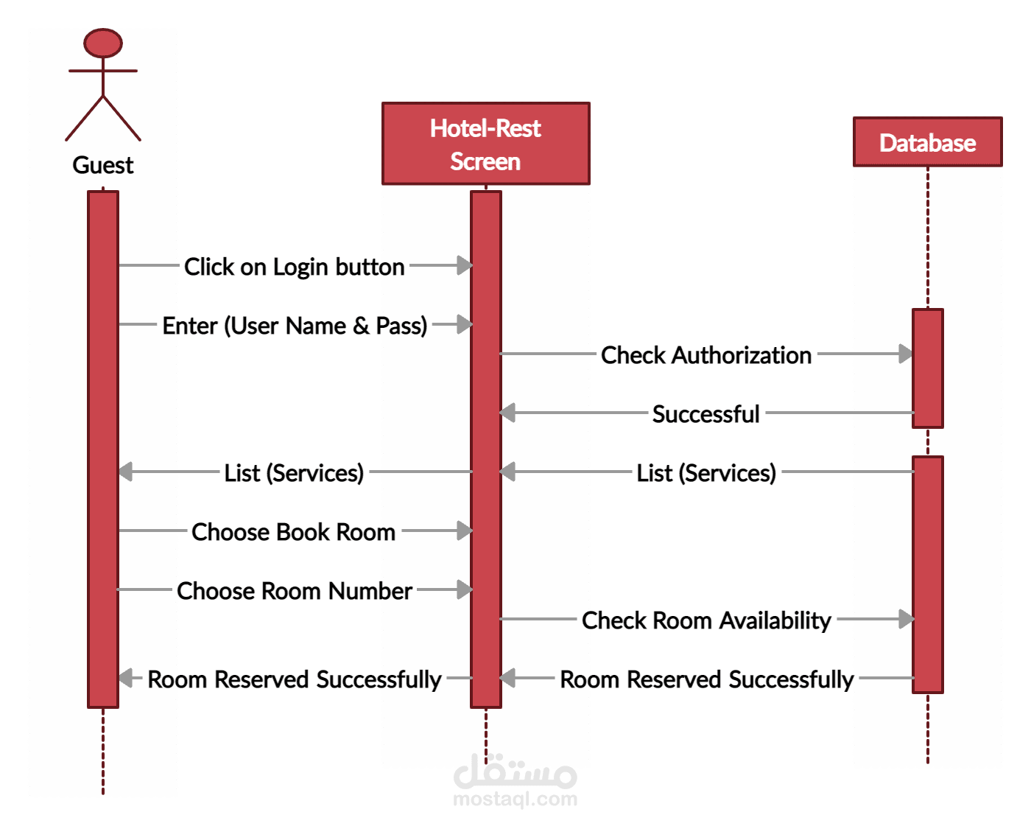

**Figure (8): User Reserve a Room Sequence Diagram**

**2.1.5 Activity Diagram**

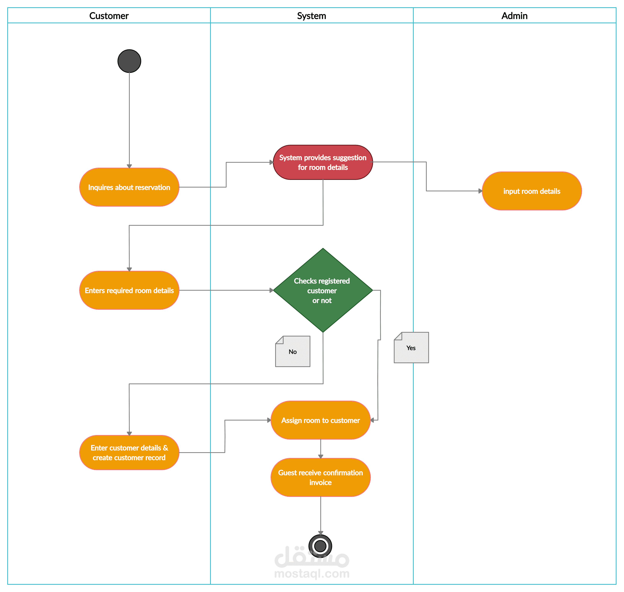

**Figure (9): Activity Diagram**

2.1.6 Data Flow Diagram (DFD)

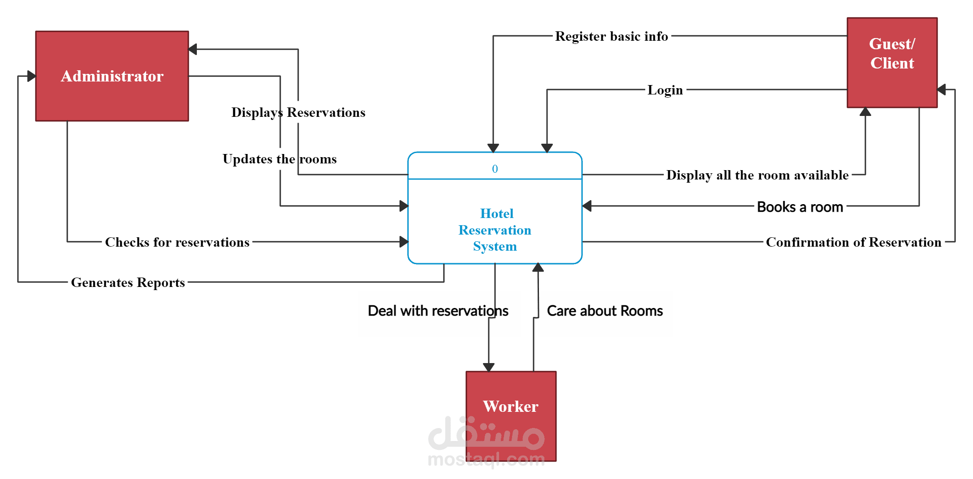

Hotel Booking App

**Figure (10): DFD**

Chapter Three: System Design

3. System Design

It is a process that includes system design for a hotel booking application and many important aspects that contribute to achieving the application objectives and providing a comfortable and secure user experience. *Here are some important points in systemic design:*

1. Database Design: We need to design a database that allows hotel information, booking, and users to be stored and retrieved effectively.

2. User interface design: An easy-to-use user interface must be designed that enables users to search for and book hotels easily.

3. Design Security and Privacy: We need to design a robust security system that properly protects users' data and sensitive transactions.

4. Performance Design: A system must be designed that allows the expected workloads to be handled efficiently and smoothly.

5. Test Design: A comprehensive testing strategy must be designed to ensure

3.1 ER-Diagram

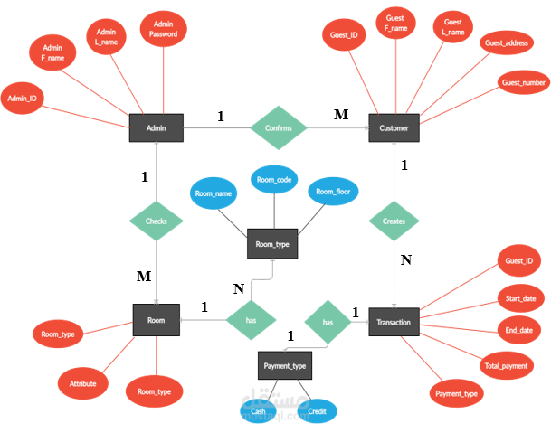

Figure (11): ER Diagram of Appointment system

3.2 User Interface (prototype)

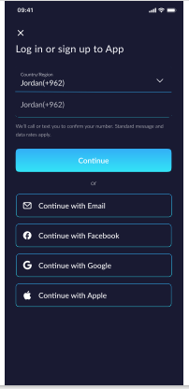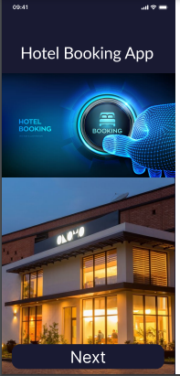

Figure 12: Start Figure 13: Login

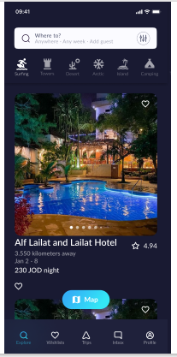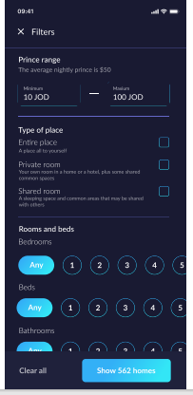

Figure 14: Explore Figure 15: Filters

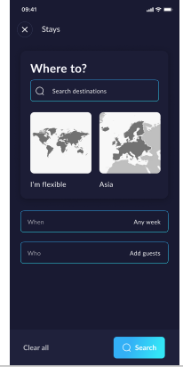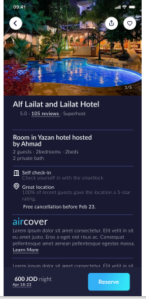

Figure 16: Where to Figure 17: Place

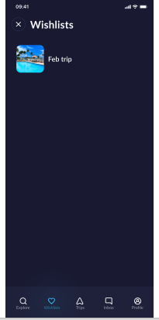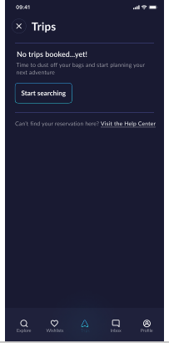

Figure 18: Wish Lists Figure 19: Trips

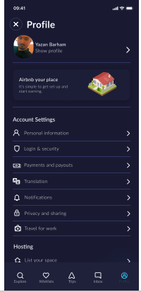

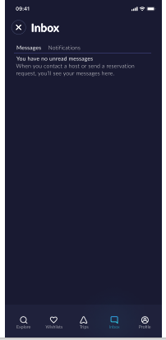

Figure 20: In Box Figure 21: Profile

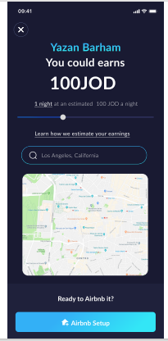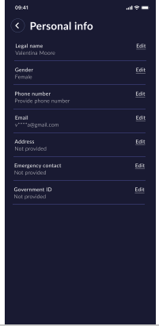

Figure 22: In Box Figure 23: Personal Info

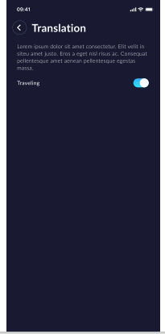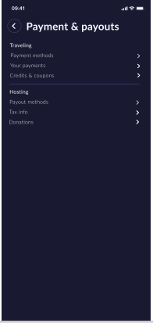

Figure 24: Payment & Payouts Figure 25: Translation

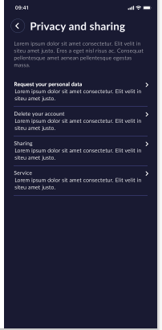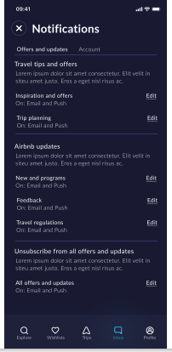

Figure 26: Notifications Figure 27: Privacy and Sharing

